Notes for CS146 Midterm

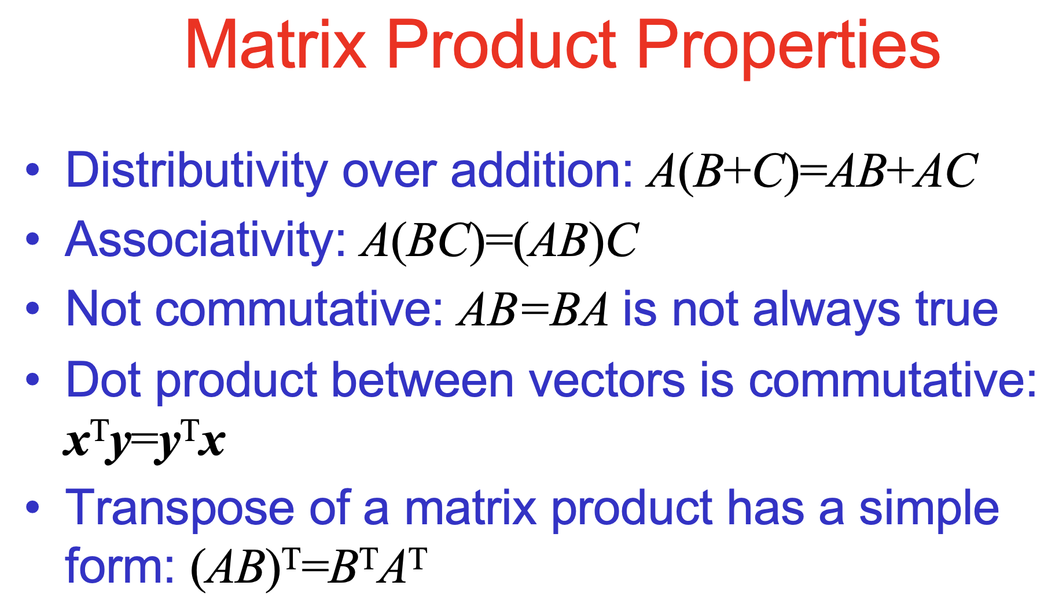

How to carry out linear regression:

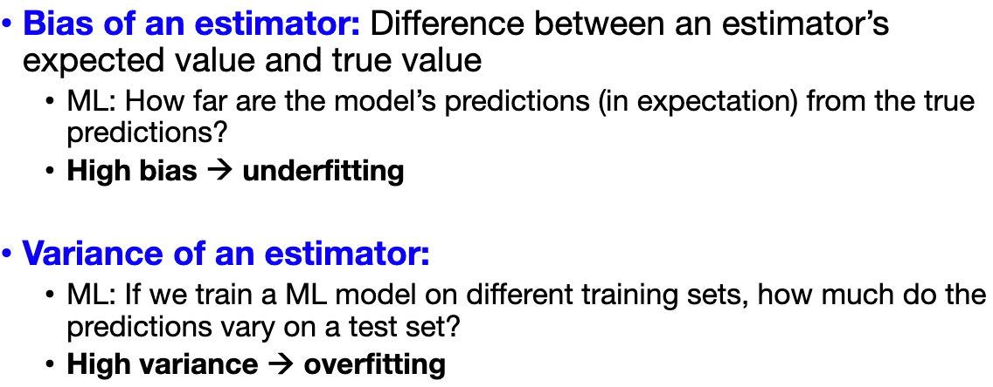

Advantages of SGD: Scales to large datasets  
• Memory efficient: single example is processed at a time  
• Computationally cheap: ! " time/step (v.s. ! #" for GD)  
• Implicit regularization (advanced ML course)  
• Disadvantages of SGD  
• High noise in the gradient. Can take many updates to converge  
• Cannot exploit modern hardware optimized for matrix

Operations

Expected square error: Bias**2 + variance

**• Loss Regularization**: Method for preventing overfitting by automatically controlling the complexity of the learned hypothesis  
• Idea: penalize large values of !" during optimization  
• Can incorporate into the loss function  
• Works well when we have a lot of features, each that contributes a bit to predicting the label

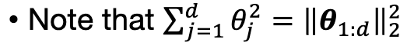

Guaranteed to converge if data is linearly separable

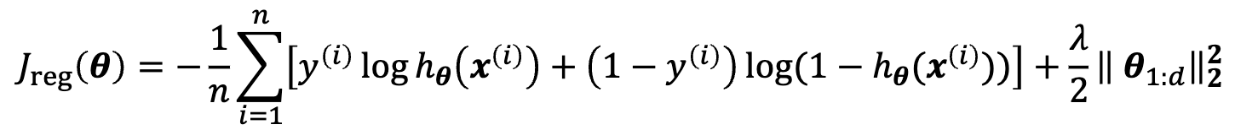

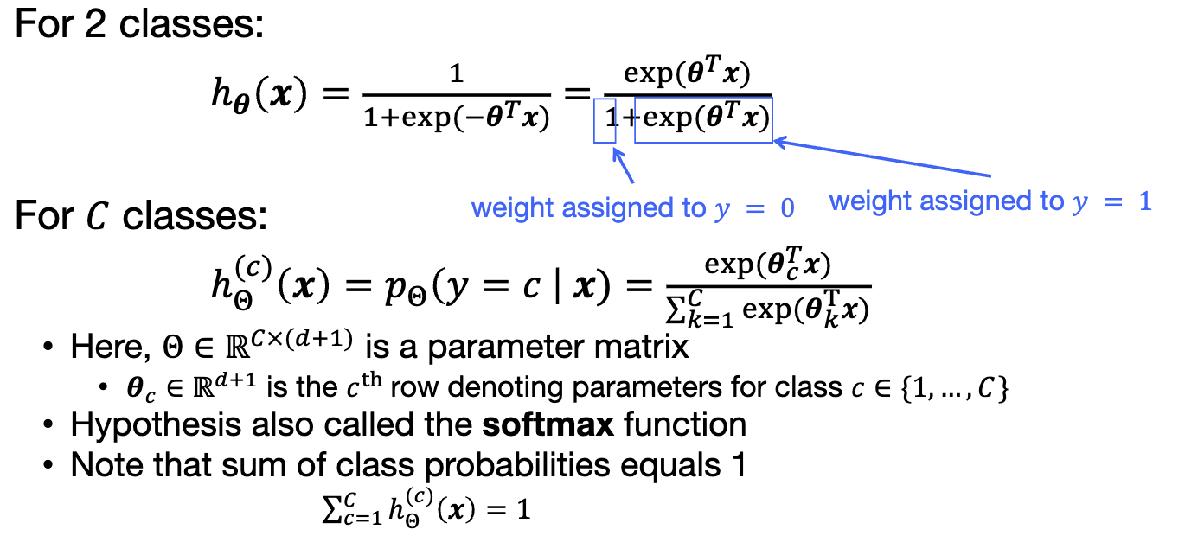

**Logistic Regression**  
• A probabilistic linear model for classification  
Loss function  
• Binary/softmax cross-entropy loss  
Basis Function, Optimization, Regularization  
• Analogous to linear regression

How to measure distances for nearest neighbor:

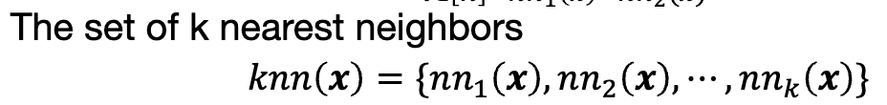

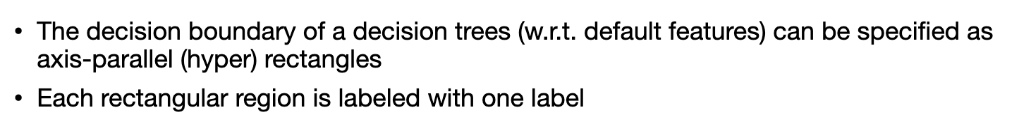

Entropy measures the level of impurity in a group of examples



